GREATER CAIRO METRO
LINE No.3 (Thawra Line)
TCMS-VVVF interface specification

Approved by | 18.Mar.2019 | K.K. SHIN | 
Reviewed by | 18.Mar.2019 | S.J. SEO | 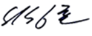
Written by | 18.Mar.2019 | H.KIM | 
 | Date | Name | Signature

Revision History
Issue | Page | Revision |  | Date
Issue | Page | Contents | Reference | Date
0 | All | First issue |  | 18.Mar.2019

Contents
1. INTRODUCTION 4
1.1. LIST OF ABBREVIATIONS 4
2. GENERAL 5
2.1. MVB Specification 5
2.2. MVB Connection 6
2.3. MVB Telegram 7
2.4. Train Formation of Cairo3 8
3. DATA EXCHANGE 10
3.1. TCMS → EBCU PBC (Powering & Braking Command) 10
3.1.1. TCMS_VVVF_EBCU_PBC 10
3.2. TCMS → EBCU SDR (Status Data Request) 11
3.2.1. TCMS-EBCU-SDR1 11
3.2.2. TCMS-EBCU-SDR2 12
3.2.3. TCMS-EBCU-SDR3 13
3.3. EBCU → TCMS SD(Status Data) 15
3.3.1. EBCUx-TCMS-SD 15
3.4. EBCU → VVVF Blending 18
3.4.1. EBCUx-VVVFy-Blending 18
3.5. VVVF → EBCU Blending 18
3.5.1. VVVFx-EBCUy-Blending 19

INTRODUCTION
This document describes the interface specification between TCMS(Data Bus System) and VVVF(e Voltage Variable Frequency) for GREATER CAIRO METRO LINE No.3 (Thawra Line) project.

LIST OF ABBREVIATIONS
TCN Train Control Network
MVB Multifunction Vehicle Bus
EMD Electrical Medium Distance
WTB Wire Train Bus
TCMS Train Control and Monitoring System
CCU Central Control Unit
VCU Vehicle Control Unit
IO-M remote IO Module
VVVF Variable Voltage Variable Frequency
DU Display Unit
RTD Remote Transmission Device
DCU Door Control Unit
ATP Automatic Train Protection
EBCU Electrical Brake Control Unit
VAC Ventilation Air conditioner Controller
TCU Traction Control Unit
APU Auxiliary Power Unit
EVR Event Recorder
HCR Header Car Relay
MF Major Fault
MCF Major Complementary Fault
HSCB High Speed Circuit Breaker
LB Line Bus Switch
PB Parking Brake
EB Emergency Brake
HB Holding Brake
FSB Full Service Brake
AUTO Automatic Mode
ADB All Door Bypass
ADC All Door Closed
AAU Automatic Announcement Unit
DCU Display Control Unit(for PA/PIS)
BC Battery Charger
HCR Head Control Relay
SDR Status Data Request
SD Status Data

GENERAL
TCMS and VVVF are interfaced with MVB. This document describes interface between TCMS and VVVF through MVB.

MVB Specification
General specification of MVB is described as follow.
-. Redundancy : Line A, Line B
-. Master / Slave : TCMS is only Master.
The subsystem needs not to act as bus administrator.
-. Media Support : EMD(Electrical Middle Distance) Communication Distance within 200m
<Table 1 Summary of the Multifunction Vehicle Bus by IEC 61375-1>
topology | bus(electrical)  star(optical)
Media | Electrical Short Distance  Electrical Middle Distance  Optical Glass Fibre | twisted wire pair, biased RS-485  shielded twisted wire pair, transformer coupled  200/240 µm fibres and star coupler
Length | Electrical Short Distance  Electrical Middle Distance  Optical Glass Fibre | 20 m, 32 devices per segment  200 m, 32 devices per segment  2000 m
Physical Redundancy | duplicated physical medium(synchronous send)
Signalling | Manchester II, 9-bit frame Start Delimiter
Signalling rate | 1.5 Mbit/s
Address space | 12-bit Device Address  (0…255 reserved for devices with Message Data capability)  12-bit Logical Address for Process Data  (each 16…256 bits)
Physical Addressing | single cast and broadcast
Frame size  (useful data) | 16, 32, 64, 128, 256 bits
Integrity | CRC-8 per 64bits + Manchester encoding, different frame Start Delimiter for Master Frame and Slave Frame against synchronization slip, reception time window supervision
Medium Allocation | by one centralized Master(Hyundai-Rotem’s CCU & VCU)
Traffic | periodic(mainly for Process Data)  sporadic(mainly for Message Data)  supervisory(for Supervisory Data)
Mastership Transfer | mastership transfer by token passing  serveral Bus Administrators can become Master in turn
Mastership Redundancy  (Option) | redundant Bus Administrators serve as back-up
Link Layer Service | Link Process Data Interface  Link Message Data Interface  Link Supervision Interface |  | broadcast of source addressed data  datagrams  Link Layer Management

MVB Connection
Where interchangeability is required, Subsystems connected by MVB shall be attached to the cable as follow:
<Table 2 Pin assignment for the EMD Connector>
1 | A.Data_P positive wire of Line A | 6 | A.Term_P, Positive pole of Terminator Line A
2 | A.Data_N negative wire of Line A | 7 | A.Term_N, Negative pole of Terminator Line A
3 | Not Used | 8 | B.Term_P, Positive pole of Terminator Line B
4 | B.Data_P positive wire of Line B | 9 | B.Term_N, Negative pole of Terminator Line B
5 | B.Data_N negative wire of Line B
Note 1 It is recommend to arrange the two connectors side by side on a device, Connector 1 on the left and Connector 2 on the right, to thread the wiring neatly.
Note 2 It may be necessary to ensure that the connector case is isolated from the device case if connection of the device cases is not advisable, for instance when large stray currents are expected.
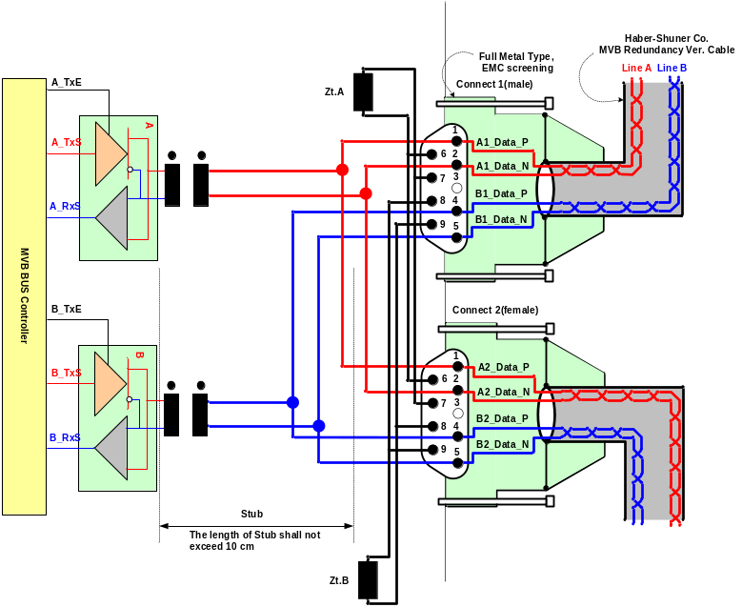
Figure 1 Double line EMD connector arrangement

MVB Telegram
There are 16 telegrams types on the MVB, which are distinguished by the F-code in Master Frame, as shown in Table 3.
Table 3 F-code of the MVB(Master Frame Type)

F-Code | Telegram Type
0 | Process Data Request with 16 bits
1 | Process Data Request with 32 bits
2 | Process Data Request with 64 bits
3 | Process Data Request with 128 bits
4 | Process Data Request with 256 bits
5 | (reserved)
6 | (reserved)
7 | (reserved)
8 | Mastership Transfer Request
9 | General Event Request
10 | (reserved)
11 | (reserved)
12 | Message Data Request
13 | Group Event Request
14 | Single Event Request
15 | Device Status Request
The basic data type for MVB network between TCMS and sub-system is WORD. Physical address is not used.
The byte ordering is the Big-Endian(Motorola) but, all data is read like word. So, the subsystem side must change like example.
The byte order and bit order for a data are as follows.
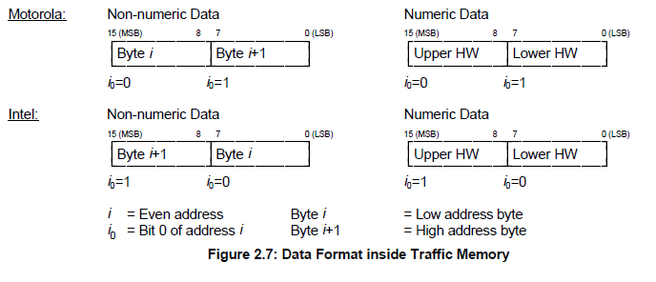
- MVB supervision :
The CCU is indicating the MVB state by the MVB watchdog counter that increases when the application is executed.
The counter from the MVB device is generated as soon as the application software is ready. If no MVB connection is established, i.e.
The MVB watchdog counter can not be received or an internal fault in the MVB device occurs, the signals, besides the watchdog counter, shall be had default value.
<Bit Ordering>
Data structures shall be numbered from left to right and from top to bottom, in the order of reading an English text. The first item on the top and to the left has offset zero.
WORD | Data Contents |  |  |  |  |  |  |  | Remark
WORD | Bit Mask |  |  |  |  |  |  |  | Remark
WORD | 15 | 14 | 13 | 12 | 11 | 10 | 9 | 8
WORD | 7 | 6 | 5 | 4 | 3 | 2 | 1 | 0
0 | 0 | 1 | 2 | 3 | 4 | 5 | 6 | 7
0 | 8 | 9 | 10 | 11 | 12 | 13 | 14 | 15
1 | 16 | 17 | 18 | 19 | 20 | 21 | 22 | 23
1 | 24 | 25 | 26 | 27 | 28 | 29 | 30 | 31
2 | 32 | 33 | 34 | 35 | 36 | 37 | 38 | 39
2 | 40 | 41 | 42 | 43 | 44 | 45 | 46 | 47
3 | 48 | 49 | 50 | 51 | 52 | 53 | 54 | 55
3 | 56 | 57 | 58 | 59 | 60 | 61 | 62 | 63
4 | 64 | 65 | 66 | 67 | 68 | 69 | 70 | 71
4 | 72 | 73 | 74 | 75 | 76 | 77 | 78 | 79
5 | 80 | 81 | 82 | 83 | 84 | 85 | 86 | 87
5 | 88 | 89 | 90 | 91 | 92 | 93 | 94 | 95
6 | 96 | 97 | 98 | 99 | 100 | 101 | 102 | 103
6 | 104 | 105 | 106 | 107 | 108 | 109 | 110 | 111
7 | 112 | 113 | 114 | 115 | 116 | 117 | 118 | 119
7 | 120 | 121 | 122 | 123 | 124 | 125 | 126 | 127
8 | 128 | 129 | 130 | 131 | 132 | 133 | 134 | 135
8 | 136 | 137 | 138 | 139 | 140 | 141 | 142 | 143
9 | 144 | 145 | 146 | 147 | 148 | 149 | 150 | 151
9 | 152 | 153 | 154 | 155 | 156 | 157 | 158 | 159
10 | 160 | 161 | 162 | 163 | 164 | 165 | 166 | 167
10 | 168 | 169 | 170 | 171 | 172 | 173 | 174 | 175
11 | 176 | 177 | 178 | 179 | 180 | 181 | 182 | 183
11 | 184 | 185 | 186 | 187 | 188 | 189 | 190 | 191
12 | 192 | 193 | 194 | 195 | 196 | 197 | 198 | 199
12 | 200 | 201 | 202 | 203 | 204 | 205 | 206 | 207
13 | 208 | 209 | 210 | 211 | 212 | 213 | 214 | 215
13 | 216 | 217 | 218 | 219 | 220 | 221 | 222 | 223
14 | 224 | 225 | 226 | 227 | 228 | 229 | 230 | 231
14 | 232 | 233 | 234 | 235 | 236 | 237 | 238 | 239
15 | 240 | 241 | 242 | 243 | 244 | 245 | 246 | 247
15 | 248 | 249 | 250 | 251 | 252 | 253 | 254 | 255

Train Formation of Cairo3
The train formation consists of 8 cars and can be seen in following figure. The detail arrangement is DTC-MC1-MC2-MCI-MCI-MC2-MC1-DTC. The two CCUs(Central Control Unit) are installed in both DTC, two VCUs are installed in MCI and two IO-Ms are installed in MC. CCU and VCU(Vehicle Control Unit) is connected to subsystem via MVB(Multifunction Vehicle Bus), WTB(Wire Train Bus) is used by the data communication interface between CCU and VCU.

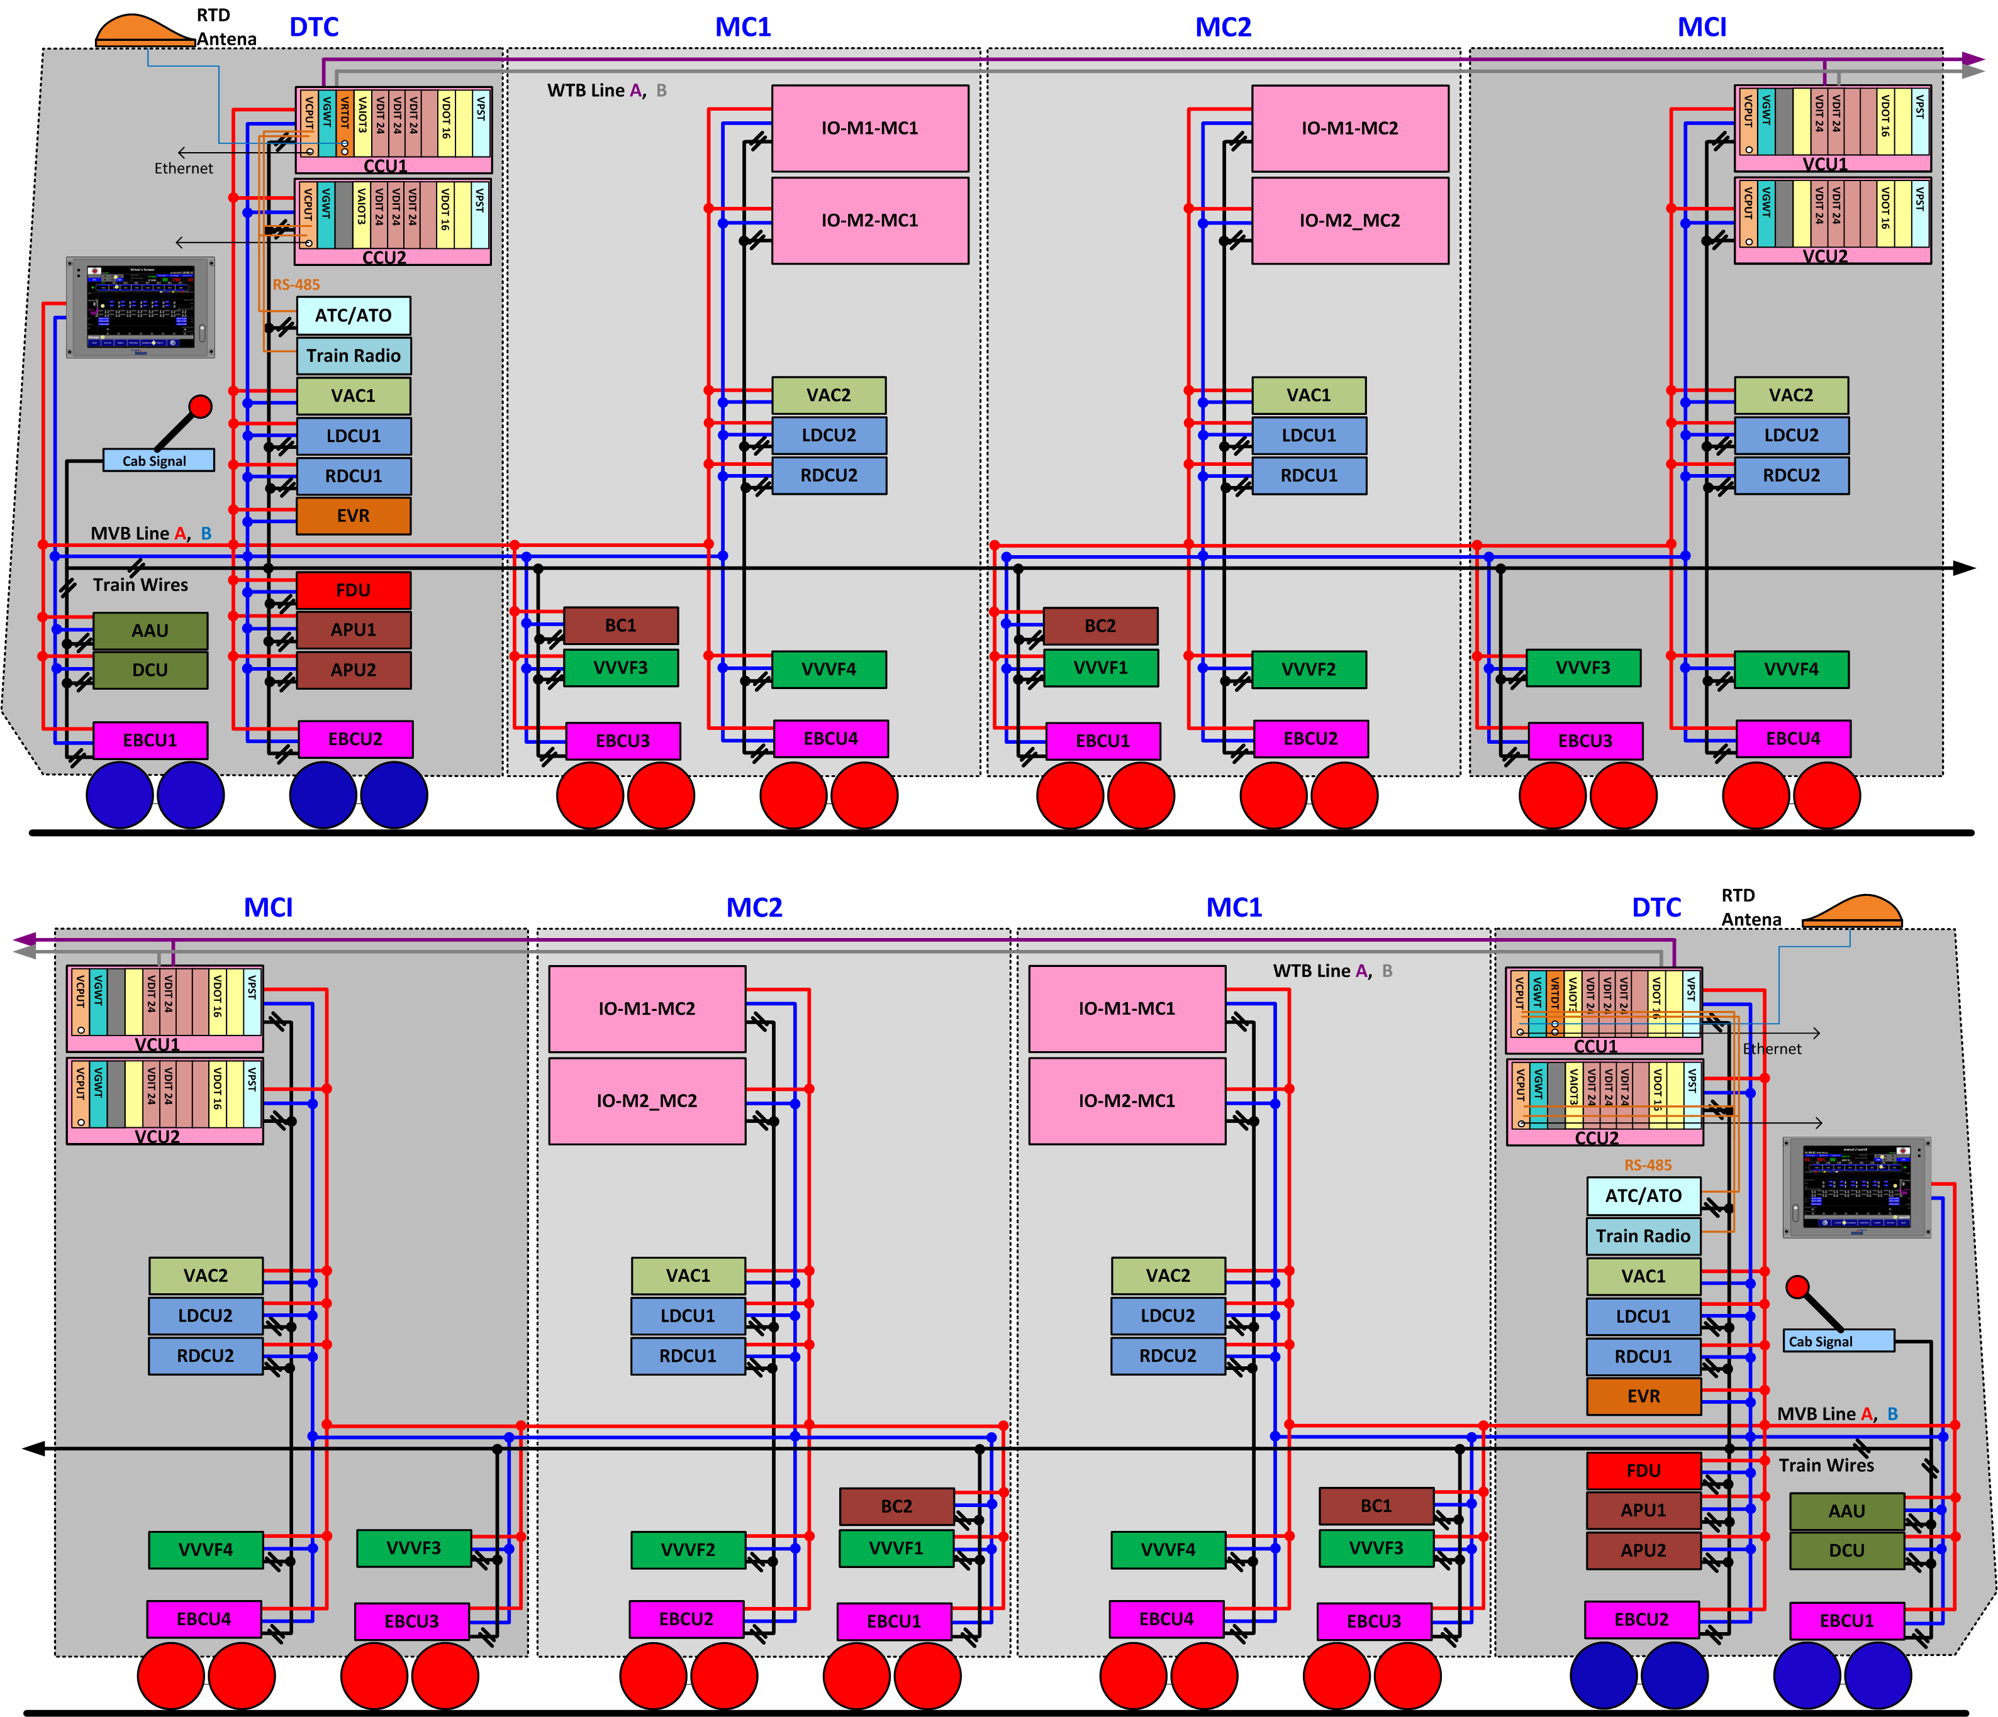

Figure 2 Configuration

DATA EXCHANGE

TCMS → EBCU PBC (Powering & Braking Command)
Telegram name | Source | Sink | Port address | Fcode | Task | Remark
TCMS_VVVF_EBCU_PBC | TCMS | EBCU ALL  VVVF ALL | 18H | 2

TCMS_VVVF_EBCU_PBC
WORD | Data Contents |  |  |  |  |  |  |  | Remark
WORD | Bit Mask |  |  |  |  |  |  |  | Remark
WORD | 15 | 14 | 13 | 12 | 11 | 10 | 9 | 8
WORD | 7 | 6 | 5 | 4 | 3 | 2 | 1 | 0
0 | ADC | EDCut |  |  |  | FullServiceBrake | ParkingBrake | EmergnecyBrake
0 | HoldingBrakeReset |  |  | ATOMode | Forward | Reverse | PoweringMode | BrakingMode
1 | PoweringDemand(0.1 %/bit resolution)
2 | BrakeDemand(0.1 %/bit resolution)
3 | WatchDogCounterPBC

Bit  Offset | Data  Size | Data  Type | Data Name | Contents | Remarks
0 | 1 | BOOL | ADC | All Door Closed(=1)
1 | 1 | BOOL | EDCut | EDCut(=1) | For VVVF
2 | 1 | BOOL
3 | 1 | BOOL | -
4 | 1 | BOOL | -
5 | 1 | BOOL | FullServiceBrake | Full Service Brake(=1)
6 | 1 | BOOL | ParkingBrake | Parking Brake(=1)
7 | 1 | BOOL | EmergnecyBrake | Emergnecy Brake(=1)
8 | 1 | BOOL | HoldingBrakeReset | Holding Brake Reset Command (“1” for 1 sec) | For EBCU
9 | 1 | BOOL
10 | 1 | BOOL
11 | 1 | BOOL | ATOMode
12 | 1 | BOOL | Forward | Motor Direction(1=Forward) | For VVVF
13 | 1 | BOOL | Reverse | Motor Direction(1=Reverse) | For VVVF
14 | 1 | BOOL | PoweringMode | 1 = Traction
15 | 1 | BOOL | BrakingMode | 1 = Braking
16 | 16 | UNSIGNED16 | PoweringDemand | 0.1 %/bit resolution
32 | 16 | UNSIGNED16 | BrakeDemand | 0.1 %/bit resolution
48 | 16 | UNSIGNED16 | WatchDogCounter | updated every 64 ms  When watchdog counter stop, brake System must be controlled by powering mode and brake mode of hardwire

TCMS → VVVF SDR (Status Data Request)
Telegram name | Source | Sink | Port address | Fcode | Task | Remark
TCMS-VVVF-SDR | TCMS | VVVF ALL | 0x58 | 4

TCMS-VVVF-SDR

WORD | Data Contents |  |  |  |  |  |  |  |  | Remark
WORD | Bit Mask |  |  |  |  |  |  |  |  | Remark
WORD | 15 |  | 14 | 13 | 12 | 11 | 10 | 9 | 8
WORD | 7 |  | 6 | 5 | 4 | 3 | 2 | 1 | 0
0
0 | Send data Counter(Watchdog : TCMS increments)  (0~255)
1 | MASCON NOTCH (for SQS) |  |  |  |  | TEST MODE
1 | P = 1  B = 0
1 | WSSC4 |  | WSSC3 | WSSC2 | WSSC1 |  | ADCS | PB | EB
2
2 | ESK |  | APUK2 | APUK1 |  |  |  |  | HB Enable
3
4 | Year(10), BCD |  |  |  |  | Year(1), BCD
4 | Month(10), BCD |  |  |  |  | Month(1), BCD
5 | Day(10), BCD |  |  |  |  | Day(1), BCD
5 | Hour(10), BCD |  |  |  |  | Hour(1), BCD
6 | Minute(10), BCD |  |  |  |  | Minute(1), BCD
6 | Second(10), BCD |  |  |  |  | Second(1), BCD
7
7 | ATP SPEED(0~255km/h)
8 | Wheel Diameter for VVVF1(0 – 80mm, 1mm/bit)
8 | Wheel Diameter for VVVF2(0 – 80mm, 1mm/bit)
9 | Wheel Diameter for VVVF3(0 – 80mm, 1mm/bit)
9 | Wheel Diameter for VVVF4(0 – 80mm, 1mm/bit)
10
10 | TCMS speed (0~255km/h)
11
12
13
14 | Status of rotary switch |  |  |  |  |  |  |  |  | Only DPRAM  (BTW VVVF DSP ↔ MON)
15

WORD 0
Bit 0-7 | Send data Counter(Watchdog : TCMS increments) | -. Range: 0 to 255 (00h to FFh)  -. TCMS increments this bit every transmission cycle. VVVF ignores the information in SDR and cut off powering if this counter is not incremented for more than "1000ms".
Bit 8
Bit 9
Bit 10
Bit 11
Bit 12
Bit 13
Bit 14
Bit 15

WORD 1
Bit 0 | EB | -. HIGH(1) : Train Emergency Brake Applied
Bit 1 | PB | -. HIGH(1) : Train Parking Brake Released
Bit 2 | ADCS | -. HIGH(1) : Train All Door Closed Status
Bit 3
Bit 4 | WSSC1 | -. Wheel Size Set Command to VVVF1.  -. When the wheel size is changed, this bit is HIGH(1) until TCMS receive the complete feedback from VVVF1.
Bit 5 | WSSC2 | -. Wheel Size Set Command to VVVF2.  -. When the wheel size is changed, this bit is HIGH(1) until TCMS receive the complete feedback from VVVF2.
Bit 6 | WSSC3 | -. Wheel Size Set Command to VVVF3.  -. When the wheel size is changed, this bit is HIGH(1) until TCMS receive the complete feedback from VVVF3.
Bit 7 | WSSC4 | -. Wheel Size Set Command to VVVF4.  -. When the wheel size is changed, this bit is HIGH(1) until TCMS receive the complete feedback from VVVF4.
Bit 8
Bit 9
Bit 10
Bit 11 | TEST MODE | -. TCMS sends the test mode for VVVF test.
Bit 12 | MASCON NOTCH(SQS)
Bit 13 | MASCON NOTCH(SQS)
Bit 14 | MASCON NOTCH(SQS)
Bit 15 | MASCON NOTCH(SQS) | -. HIGH(1) : P  -. LOW(0) : B

WORD 2
Bit 0
Bit 1
Bit 2
Bit 3
Bit 4
Bit 5 | APUK1
Bit 6 | APUK2
Bit 7 | ESK
Bit 8
Bit 9
Bit 10
Bit 11
Bit 12
Bit 13
Bit 14
Bit 15

WORD 3
Bit 0-7
Bit 8-15

WORD 4
Bit 0-3 | Month(1), BCD | -. Range: 0 to 9 (BCD)  -. TCMS sets the value of the first figure of month.
Bit 4-7 | Month(10), BCD | -. Range: 0 to 9 (BCD)  -. TCMS sets the value of the second figure of month.
Bit 8-11 | Year(1), BCD | -. Range: 0 to 9 (BCD)  -. TCMS sets the value of the first figure of year in lower two digit of Christian era.
Bit 12-15 | Year(10), BCD | -. Range: 0 to 9 (BCD)  -. TCMS sets the value of the second figure of year in lower two digit of Christian era.

WORD 5
Bit 0-3 | Hour(1), BCD | -. Range: 0 to 9 (BCD)  -. TCMS sets the value of the first figure of hour.
Bit 4-7 | Hour(10), BCD | -. Range: 0 to 9 (BCD)  -. TCMS sets the value of the second figure of hour.
Bit 8-11 | Day(1), BCD | -. Range: 0 to 9 (BCD)  -. TCMS sets the value of the first figure of day.
Bit 12-15 | Day(10), BCD | -. Range: 0 to 9 (BCD)  -. TCMS sets the value of the second figure of day.

WORD 6
Bit 0-3 | Second (1), BCD | -. Range: 0 to 9 (BCD)  -. TCMS sets the value of the first figure of second.
Bit 4-7 | Second (10), BCD | -. Range: 0 to 9 (BCD)  -. TCMS sets the value of the second figure of second.
Bit 8-11 | Minute (1), BCD | -. Range: 0 to 9 (BCD)  -. TCMS sets the value of the first figure of minute.
Bit 12-15 | Minute (10), BCD | -. Range: 0 to 9 (BCD)  -. TCMS sets the value of the second figure of minute.

WORD 7
Bit 0-7 | ATP SPEED | -. ATP SPEED .  -. Range : 0 – 255km/h, 0x00-0xFF, 1km/h/bit
Bit 8-15

WORD 8
Bit 0-7 | Wheel Diameter for VVVF2 | -. Wheel Diameter for VVVF2  -. Range : 0 – 80mm, (offset : 770mm)
Bit 8-15 | Wheel Diameter for VVVF1 | -. Wheel Diameter for VVVF1  -. Range : 0 – 80mm, (offset : 770mm)

WORD 9
Bit 0-7 | Wheel Diameter for VVVF4 | -. Wheel Diameter for VVVF4  -. Range : 0 – 80mm, (offset : 770mm)
Bit 8-15 | Wheel Diameter for VVVF3 | -. Wheel Diameter for VVVF3  -. Range : 0 – 80mm, (offset : 770mm)

WORD 10
Bit 0-7 | TCMS SPEED | TCMS speed (0~255km/h)
Bit 8-15

WORD 11
Bit 0-15

WORD 12
Bit 0-15

WORD 13
Bit 0-15

WORD 14
Bit 0-15

WORD 15
Bit 0-15

VVVF → TCMS SD(Status Data)
Telegram name | Source | Sink | Port address | Fcode | Task | Remark
VVVF1-TCMS-SD1 | VVVF1 | TCMS | 50H | 4
VVVF2-TCMS-SD1 | VVVF2 | TCMS | 60H | 4
VVVF3-TCMS-SD1 | VVVF3 | TCMS | 70H | 4
VVVF4-TCMS-SD1 | VVVF4 | TCMS | 80H | 4
VVVF1-TCMS-SD2 | VVVF1 | TCMS | 54H | 4
VVVF2-TCMS-SD2 | VVVF2 | TCMS | 64H | 4
VVVF3-TCMS-SD2 | VVVF3 | TCMS | 74H | 4
VVVF4-TCMS-SD2 | VVVF4 | TCMS | 84H | 4

VVVFx-TCMS-SD1

WORD | Data Contents |  |  |  |  |  |  |  |  |  |  |  |  |  |  | Remark
WORD | Bit Mask |  |  |  |  |  |  |  |  |  |  |  |  |  |  | Remark
WORD | 15 | 14 |  | 13 |  | 12 |  | 11 |  | 10 |  | 9 |  | 8
WORD | 7 | 6 |  | 5 |  | 4 |  | 3 |  | 2 |  | 1 |  | 0
0 | SD type  VVVF1 : 21H, VVVF2 : 22H, VVVF3 : 23H, VVVF4 : 24H
0 | Send data Counter(Watchdog : VVVF increments)  (0~255)
1 | Axle1Speed (Axle1), 0 ~ 12,000, 100=1km/h  Range : 0~120km/h
2 | Axle2Speed (Axle1), 0 ~ 12,000, 100=1km/h  Range : 0~120km/h
3 | APBR (Actual powering/brake command)  Powering +10,000(100kN) ~ +1 / Braking -1 ~ -10,000(100kN)
4 | LV(Line voltage, 0 ~ 60,000, 10 = 1V)  Range : 0~6,000V
5 | FC(FC direct voltage, 0 ~ 60,000, 10 = 1V)  Range : 0~6,000V
6 | IRMS(Motor current, 10 = 1A)
7 | DC_CURRENT(10=1A)
8 | WHP(0~6553.5kw/h)
9 | WHB(0~6553.5kw/h)
10 | Wheel set  Invalid |  | Holding Brake Release |  |  |  | Heavy  WSD |  | WSDB in axle 2 |  | WSDB in axle 1 |  | WSDP in axle 2 |  | WSDP in axle 1 | Status
10 | INVOK |  | ACTIVE |  | RESET |  | CCS |  | ETRA |  | EBA |  | GATEON |  | SQS | Status
11 | TE_H/W |  | PBLSP |  | RCUT |  | BOTH |  | FO |  | CDR |  | WSCFB |  | POTH | Status  (red color box : fault)
11 | F |  | R |  | BROP |  | P |  | B |  | CCKC |  | LBC |  | HBC | Status  (red color box : fault)
12 | HBON |  | CCKON |  | LBON |  | CIDOK |  | ESA |  | PAND |  | EO |  | REV | Status
12 | BPSF |  | SPSF |  | APSF |  | BOT |  | IOCD |  | MOCD |  | BOCD |  | PUD | Fault
13 | VLLVD |  | FCLVD |  | FCOVD |  | PGD |  | OLD |  | HBTF |  | LGD |  | DCD  POT | Fault
13 | CIDF |  | FCD |  | FRF |  | PBF |  | BSD |  | CTF_L2  FNOT |  | CTF_L1  VTIF |  | COMF | Fault
14 | BROT |  | GDFZ |  | GDFY |  | GDFX |  | GDFW |  | GDFV |  | GDFU |  | GDFB | Fault
14 | HBOF |  | HBCF |  | CKCF |  | CKOF |  | LBCF |  | LBOF |  | LOVD |  |  | Fault
15 | RVER(Software Version, XX.00)
15 | RVER(Software Version, 00.XX)

WORD 0
Bit 0-7 | Send data Counter(Watchdog : VVVF increments) | -. Range: 0 to 255 (00h to FFh)  -. VVVF increments this bit every transmission cycle. TCMS ignores the information in SD if this counter is not incremented for more than "1000ms".
Bit 8-15 | SD type | -. Range: 21h, 22h, 23h, 24h  -. VVVF sets SD type according to the car number.  VVVF1 : 21H  VVVF2 : 22H  VVVF3 : 23H  VVVF4 : 24H

WORD 1
Bit 0-15 | Axle1Speed | -. Axle Speed for Axle 1  -. Range : 0 ~ 12,000, 100=1km/h

WORD 2
Bit 0-15 | Axle2Speed | -. Axle Speed for Axle 2  -. Range : 0 ~ 12,000, 100=1km/h

WORD 3
Bit 0-15 | APBR | -. Actual Powering / Braking Command of VVVF  -. Powering +10,000(100kN) ~ +1 / 0 / Braking -1 ~ -10,000(100kN)

WORD 4
Bit 0-15 | ES | -. Actual Line Voltage checked by VVVF  -. 0 ~ 60,000, 10 = 1V (0~6,000V)

WORD 5
Bit 0-15 | FC | -. FC direct voltage  -. 0 ~ 60,000, 10 = 1V (0~6,000V)

WORD 6
Bit 0-15 | IRMS | -. Actual Motor Current checked by VVVF  -. 0 ~ 20,000, 10 = 1A (0~2,000A)

WORD 7
Bit 0-15 | DC current | -. Actual Line Current checked by VVVF  -. 0 ~ 20,000, 10 = 1A (0~2,000A)

WORD 8
Bit 0-15 | WHP | Watt-hour meter for powering  -. Range: 0 to 6553.5 kWh (0000h to FFh, 100Wh/bit)  When incremented from 6553.5 kWh ("FFFFh"), the value will be 0 kWh (“00h"). And the numbers will be reset to zero when VVVF is powered down.

WORD 9
Bit 0-15 | WHB | Watt-hour meter for braking  -. Range: 0 to 6553.5 kWh (0000h to FFh, 100Wh/bit)  When incremented from 6553.5 kWh ("FFFFh"), the value will be 0 kWh (“00h"). And the numbers will be reset to zero when VVVF is powered down.

WORD 10
Bit 0 | SQS | -. HIGH(1) : Test Mode
Bit 1 | GATEON | -. HIGH(1) : Gate Control ON
Bit 2 | EBA | -. HIGH(1) : Emergency Brake
Bit 3 | ETRA | -. HIGH(1) : Emergency trip acknowledge
Bit 4 | CCS | -. HIGH(1) : Control Cut-out status
Bit 5 | RESET | -. HIGH(1) : VVVF reset status
Bit 6 | ACTIVE | -. HIGH(1) : VVVF active status
Bit 7 | INVOK | -. HIGH(1) : Inverter OK status
Bit 8 | slip detect in axle 1 | -. Slip detect in axle 1
Bit 9 | slip detect in axle 2 | -. Slip detect in axle 2
Bit 10 | slide detect in axle 1 | -. Slide detect in axle 1
Bit 11 | slide detect in axle 2 | -. Slide detect in axle 2
Bit 12 | Heavy WSD | -. Heavy Slip / Slide detect detect (more than 5s)
Bit 13
Bit 14 | Holding Brake Release | -. HIGH(1) : Holding Brake Release
Bit 15 | Wheel set Invalid | TCMS 정보와 VVVF 정보 불일치 신호 , DU화면상에 휠셋정보 리셋 메시지 추가 요청

WORD 11
Bit 0 | HBC | -. HIGH(1) : HB close command
Bit 1 | LBC | -. HIGH(1) : LB close command
Bit 2 | CCKC | -. HIGH(1) : CCK close command
Bit 3 | B | -. HIGH(1) : Braking mode
Bit 4 | P | -. HIGH(1) : Powering mode
Bit 5
Bit 6 | R | -. HIGH(1) : Reverse
Bit 7 | F | -. HIGH(1) : Forward
Bit 8 | POTH | -. HIGH(1) : Inverter over temperature
Bit 9 | WSCFB | -. After new wheel diameter set, VVVF send back the completion status.  -. HIGH(1) : Wheel Diameter Set Complete Feed-back
Bit 10 | CDR | -. HIGH(1) : Regenerate brake effort is valid.
Bit 11 | FO | -. HIGH(1) : Regenerate brake effort is fade-out.
Bit 12 | BOTH | -. HIGH(1) : BCH over temperature
Bit 13 | RCUT | -. HIGH(1) : Regenerate brake effort cut-out.
Bit 14 | PBLSP | -. HIGH(1) : Propulsion block-speed measurement error
Bit 15 | TE_HW | -. HIGH(1) : Traction Enable from Hardwire

WORD 12
Bit 0 | PUD | -. HIGH(1) : Motor current unbalance detect
Bit 1 | BOCD | -. HIGH(1) : Brake chopper over current detect
Bit 2 | MOCD | -. HIGH(1) : Motor over current detect
Bit 3 | IOCD | -. HIGH(1) : Input over current detect
Bit 4 | BOT | -. HIGH(1) : BCH over temperature
Bit 5 | APSF | -. HIGH(1) : Analogue power fault
Bit 6 | SPSF | -. HIGH(1) : Sensor power fault
Bit 7 | BPSF | -. HIGH(1) : Battery power fault
Bit 8 | REV | -. HIGH(1) : Reverse detection
Bit 9 | EO | -. HIGH(1) : Emergency Back-up mode
Bit 10 | PAND | -. HIGH(1) : Emergency Panto down
Bit 11 | ESA | -. HIGH(1) : Earth switching ON status
Bit 12 | CIDOK | -. HIGH(1) : CID ok
Bit 13 | LBON | -. HIGH(1) : LB ON status
Bit 14 | CCKON | -. HIGH(1) : CCK ON status
Bit 15 | HBON | -. HIGH(1) : HB ON status

WORD 13
Bit 0 | COMF | -. HIGH(1) : Communication fault
Bit 1 | VTIF | -. HIGH(1) : VTI fault
Bit 2 | FNOT | -. HIGH(1) : Fan over temperature
Bit 3 | BSD | -. HIGH(1) : Backward speed detect
Bit 4 | PBF | -. HIGH(1) : Powering/braking command fault
Bit 5 | FRF | -. HIGH(1) : Forward/reverse fault
Bit 6 | FCD | -. HIGH(1) : FC charging fault
Bit 7 | CIDF | -. HIGH(1) : CID fault
Bit 8 | POT | HIGH(1) : Inverter over temperature
Bit 9 | LGD | -. HIGH(1) : Line ground detect
Bit 10 | HBTF | -. HIGH(1) : HB trip detect
Bit 11 | OLD | -. HIGH(1) : Overload detect
Bit 12 | PGD | -. HIGH(1) : PG fault
Bit 13 | FCOVD | -. HIGH(1) : FC over voltage detect
Bit 14 | FCLVD | -. HIGH(1) : FC low voltage detect
Bit 15 | VLLVD | -. HIGH(1) : Line low voltage detect

WORD 14
Bit 0
Bit 1 | LOVD | -. HIGH(1) : Line Over voltage detection
Bit 2 | LBOF | -. HIGH(1) : Line Breaker open fault
Bit 3 | LBCF | -. HIGH(1) : Line Breaker close fault
Bit 4 | CKOF | -. HIGH(1) : Charging contactor open fault
Bit 5 | CKCF | -. HIGH(1) : Charging contactor close fault
Bit 6 | HBCF | -. HIGH(1) : HSCB close fault
Bit 7 | HBOF | -. HIGH(1) : HSCB open fault
Bit 8 | GDFB | -. HIGH(1) : Gate Drive Fault, Brake Chopper
Bit 9 | GDFU | -. HIGH(1) : Gate Drive Fault, Phase U
Bit 10 | GDFV | -. HIGH(1) : Gate Drive Fault, Phase V
Bit 11 | GDFW | -. HIGH(1) : Gate Drive Fault, Phase W
Bit 12 | GDFX | -. HIGH(1) : Gate Drive Fault, Phase X
Bit 13 | GDFY | -. HIGH(1) : Gate Drive Fault, Phase Y
Bit 14 | GDFZ | -. HIGH(1) : Gate Drive Fault, Phase Z
Bit 15 | BROT | -. HIGH(1) : Brake Resistor Overheat Precaution

WORD 15
Bit 0-7 | RVER(00.XX) | -. Software Version  -. If value is 0xA, it means version “00.10”.
Bit 8-15 | RVER(XX.00) | -. Software Version  -. If value is 0xA, it means version “10.00”.

VVVFx-TCMS-SD2
WORD | Data Contents |  |  |  |  |  |  |  |  |  |  |  |  |  |  | Remark
WORD | Bit Mask |  |  |  |  |  |  |  |  |  |  |  |  |  |  | Remark
WORD | 15 | 14 |  | 13 |  | 12 |  | 11 |  | 10 |  | 9 |  | 8
WORD | 7 | 6 |  | 5 |  | 4 |  | 3 |  | 2 |  | 1 |  | 0
0 | SD type  VVVF1 : 25H, VVVF2 : 26H, VVVF1 : 27H, VVVF2 : 28H
0 | Send data Counter(Watchdog : VVVF increments)  (0~255)
1 | Stack INV Temperature -128 ~ 128, 1=1℃
1 | Stack BCH Temperature -128 ~ 128, 1=1℃
2
2 | Total time summation of BCH on duty 0-255  (0~25.5s) , 10=1sec
3 | Iqse* 0~255 A , 1=1A
3 | Iqse_real 0~255 A , 1=1A
4 | Lamdre* -128 ~ 128  (-12.8 ~ 12.8 Wb) , 10=1Wb
4 | Lamdre -128 ~ 128  (-12.8 ~ 12.8 Wb) , 10=1Wb
5 | ED Brake Request for VVVF 0~200  (0~100%) , 2=1%
5 | ED Brake Achieved for VVVF 0~200  (0~100%) , 2=1%
6 | BCH_duty 0 ~ 200 (0 ~ 100%), 2=1%
7 | Modulation ratio 0 ~ 200 (0 ~ 100%), 2=1%
8 | Wheel Diameter (INV)  Range : 0 – 80mm, (offset : 770mm)
8 | Wheel Diameter (TCMS)  Range : 0 – 80mm, (offset : 770mm)
9 | PRCMD(0% - 100%, 1%/bit)
9 | BRCMD(0% - 100%, 1%/bit)
10 | MON Software Version X.0 (BCD) |  |  |  |  |  |  |  | MON Software Version 0.X (BCD)
11
12
13
14
15

WORD 0
Bit 0-7 | Send data Counter(Watchdog : VVVF increments) | -. Range: 0 to 255 (00h to FFh)  -. VVVF increments this bit every transmission cycle. TCMS ignores the information in SD if this counter is not incremented for more than "1000ms".
Bit 8-15 | SD type | -. Range: 25h, 26h, 27h, 28h  -. VVVF sets SD type according to the car number.  VVVF1 : 25H  VVVF2 : 26H  VVVF3 : 27H  VVVF4 : 28H

WORD 1
Bit 0-7 | BCH Temp | -. Stack BCH Temperature -128 ~ 128, 1=1℃
Bit 8-15 | INV Tmep | -. Stack INV Temperature -128 ~ 128, 1=1℃

WORD 2
Bit 0-7 | Total_time | -. Total time summation of BCH on duty 0~255  (0~25.6s) , 10=1sec
Bit 8-15 | Spare | Spare

WORD 3
Bit 0-7 | Iqse_real | -. Iqse_real 0~255 A
Bit 8-15 | Iqse* | -. Iqse* 0~255 A

WORD 4
Bit 0-7 | Lamdre | -. Lamdre -128 ~ 128  (-12.8 ~ 12.8 Wb) , 10=1Wb
Bit 8-15 | Lamdre* | -. Lamdre* -128 ~ 128  (-12.8 ~ 12.8 Wb) , 10=1Wb

WORD 5
Bit 0-7 | EDBRa | -. ED Brake Achieved for VVVF 0~200  (0~100%) , 2=1%
Bit 8-15 | EDBR | -. ED Brake Request for VVVF 0~200  (0~100%) , 2=1%

WORD 6
Bit 0-7 | Spare | -. Spare
Bit 8-15 | BCH-duty | -. BCH_duty 0 ~ 200 (0 ~ 100%)

WORD 7
Bit 0-7 | Spare | -. Spare
Bit 8-15 | MM | -. Modulation ratio 0 ~ 200 (0 ~ 100%)

WORD 8
Bit 0-7 | Wheel Diameter  (INV) | -. Wheel Diameter (INV)  -. Range : 0 – 80mm, (offset : 770mm)
Bit 8-15 | Wheel Diameter  (TCMS) | -. Wheel Diameter (TCMS)  -. Range : 0 – 80mm, (offset : 770mm)

WORD 9
Bit 0-7 | BRCMD | -. Brake Command (0% - 100%, 1%/bit)
Bit 8-15 | PRCMD | -. Powering Command (0% - 100%, 1%/bit)

WORD 10
Bit 0-7 | Spare | -. Spare
Bit 8-15 | Spare | -. Spare

WORD 11
Bit 0-7
Bit 8-15

WORD 12
Bit 0-7
Bit 8-15

WORD 13
Bit 0-7 | Spare | -. Spare
Bit 8-15 | Spare | -. Spare

WORD 14
Bit 0 | Spare | -. Spare
Bit 1 | Spare | -. Spare
Bit 2 | Spare | -. Spare
Bit 3 | Spare | -. Spare
Bit 4 | Spare | -. Spare
Bit 5 | Spare | -. Spare
Bit 6 | Spare | -. Spare
Bit 7 | Spare | -. Spare
Bit 8 | Spare | -. Spare
Bit 9 | Spare | -. Spare
Bit 10 | Spare | -. Spare
Bit 11 | Spare | -. Spare
Bit 12 | Spare | -. Spare
Bit 13 | Spare | -. Spare
Bit 14 | Spare | -. Spare
Bit 15 | Spare | -. Spare

WORD 15
Bit 0-7
Bit 8-15 | Spare | -. Spare

EBCU → VVVF Blending
Telegram name | Source | Sink | Port address | Fcode | Task | Remark
EBCU1-VVVF1-Blending | EBCU1 | VVVF1 | 1CH | 2 |  | DTC excluded
EBCU2-VVVF2 -Blending | EBCU2 | VVVF2 | 2CH | 2 |  | DTC excluded
EBCU3-VVVF3-Blending | EBCU3 | VVVF3 | 3CH | 2
EBCU4-VVVF4-Blending | EBCU4 | VVVF4 | 4CH | 2

EBCUx-VVVFy-Blending
WORD | Data Contents |  |  |  |  |  |  |  | Remark
WORD | Bit Mask |  |  |  |  |  |  |  | Remark
WORD | 15 | 14 | 13 | 12 | 11 | 10 | 9 | 8
WORD | 7 | 6 | 5 | 4 | 3 | 2 | 1 | 0
0 |  |  |  |  |  |  |  | EDCut
0 | WatchdogCounter_EBCU_Blending
1 | LoadWeight(0 – 800TON / 0x00 – 0x1F40, 0.1Ton/bit)
2 | BED(0 – 80kN/0x00 – 0x1F40, 0.01kN/bit)
3

Bit Offset | Data Size | Data Type | Data Name | Contents | Remark
0 | 1 | BOOL
1 | 1 | BOOL
2 | 1 | BOOL
3 | 1 | BOOL
4 | 1 | BOOL
5 | 1 | BOOL
6 | 1 | BOOL
7 | 1 | BOOL | EDCUT | ED Brake CutOut Command(EBCU→VVVF)
8 | 8 | UNSIGNED8 | WatchdogCounter_EBCU_Blending | Watchdog Counter(0 ~255)
16 | 16 | UNSIGNED16 | LoadWeight | Load Weight for VVVF  0 – 800TON / 0x0000 – 0x1F40, 0.1Ton/bit
32 | 16 | UNSIGNED16 | BED | ED Brake Request to VVVF  0 – 800kN / 0x0000 – 0x0x1F40, 0.1kN/bit
48 | 16

VVVF → EBCU Blending
Telegram name | Source | Sink | Port address | Fcode | Task | Remark
VVVF1-EBCU1-Blending | VVVF1 | EBCU1 | 0x68 | 2 |  | DTC excluded
VVVF2-EBCU2-Blending | VVVF2 | EBCU2 | 0x6C | 2 |  | DTC excluded
VVVF3-EBCU3-Blending | VVVF3 | EBCU3 | 0x78 | 2
VVVF4-EBCU4-Blending | VVVF4 | EBCU4 | 0x7C | 2

VVVFx-EBCUy-Blending
WORD | Data Contents |  |  |  |  |  |  |  | Remark
WORD | Bit Mask |  |  |  |  |  |  |  | Remark
WORD | 15 | 14 | 13 | 12 | 11 | 10 | 9 | 8
WORD | 7 | 6 | 5 | 4 | 3 | 2 | 1 | 0
0 |  |  | EDBOK | MCV(Motor Current Valid) | BCV(BEA valid) | FO | WSD | VVVFEDCutStatus
0 | WatchdogCounter_TCU_Blending
1 | BEA(0 – 80kN / 0x0000 – 0x1F40, 0.01kN/bit)
2
3

Bit Offset | Data Size | Data Type | Data Name | Contents | Remark
0 | 8 | BOOL
1 | 1 | BOOL
2 | 1 | BOOL | EDBOK | 1: ED Brake OK response from VVVF
3 | 1 | BOOL | MCV(Motor Current Valid) | 1: motor current is valid
4 | 1 | BOOL | BCV(BEA valid) | 1: ED Brake Achieved(BEA) valid
5 | 1 | BOOL | FO | 1: Electrical Brake Fade-out
6 | 1 | BOOL | WSD | 1: ED Brake WSP response from VVVF
7 | 1 | BOOL | VVVFEDCutStatus | 1: ED Brake
8 | 8 | UNSIGNED8 | WatchdogCounter_TCU_Blending | Watchdog Counter(0 ~255)
16 | 1 | UNSIGNED16 | BEA | ED Brake Achieved Response from VVVF  0 – 800kN / 0x0000 – 0x0x1F40, 0.1kN/bit

